CS 255 System Design Document Template

This template lays out all the different sections that you need to complete for Project Two. Each section has guidance to prompt your thinking. You will need to continually reference the interview transcript as you work to make sure that you are addressing your client’s needs. There is no required length for the final document. Instead the goal is to complete each section based on what your client’s needs are. Remove this note when you are finished, and replace all bracketed text with the relevant information.

UML Diagrams

UML Use Case Diagram
[In Module Six, you were asked to complete a use case diagram based on your system design. If you would like to make any adjustments to your diagram, please do so. Please insert your use case diagram here. Check to make sure that you included appropriate components and symbols and that your design meets the client’s needs.]
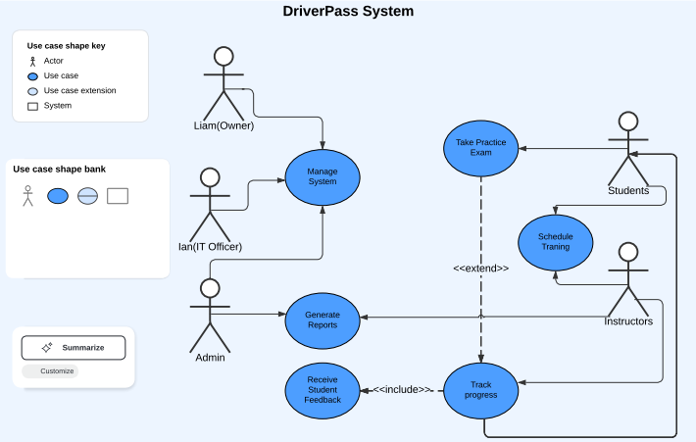

UML Activity Diagrams
[You were asked to choose two use cases and create two activity diagrams, one for each use case. Please insert both of your activity diagrams here. Check to make sure that you included appropriate components and symbols and that your design meets the client’s needs.]

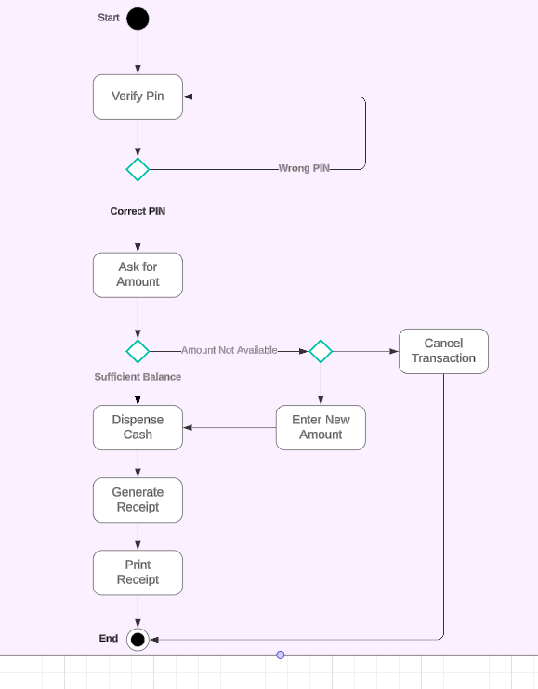

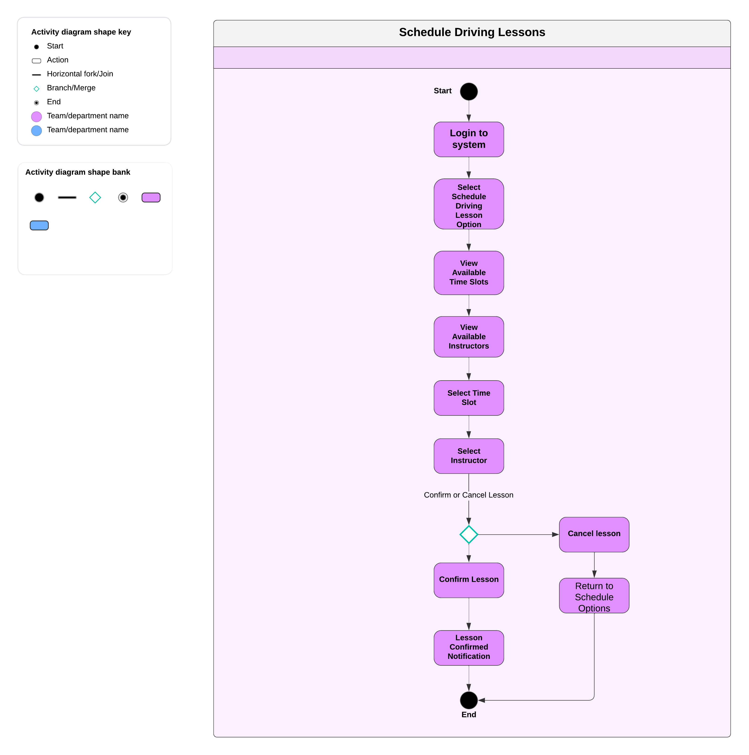

UML Sequence Diagram
[You were asked to create a sequence diagram based on one of the use cases you chose. Please insert your sequence diagram here. Check to make sure that you included appropriate components and symbols and that your design meets the client’s needs.]
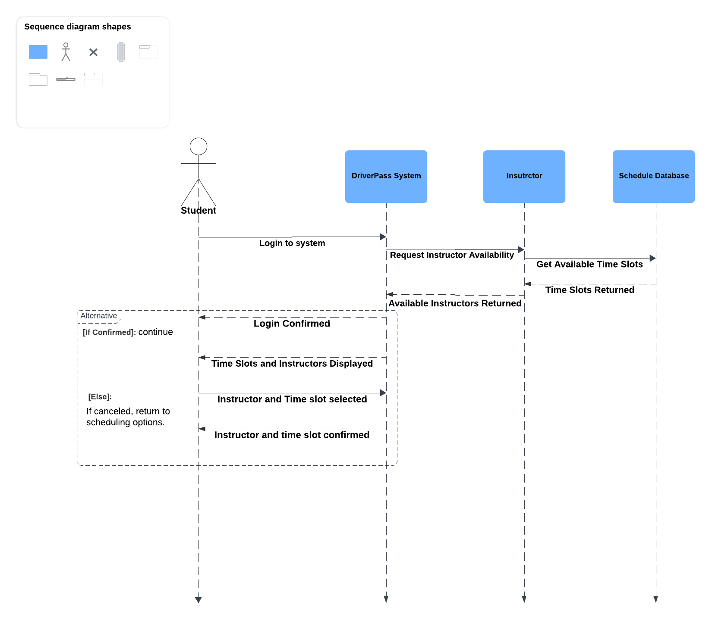

UML Class Diagram
[You were asked to create a class diagram based on the different classes and attributes needed for your system design. You are not required to include methods, but you may if you wish. Please insert your class diagram here. Check to make sure that you included appropriate components and symbols and that your design meets the client’s requirements.]
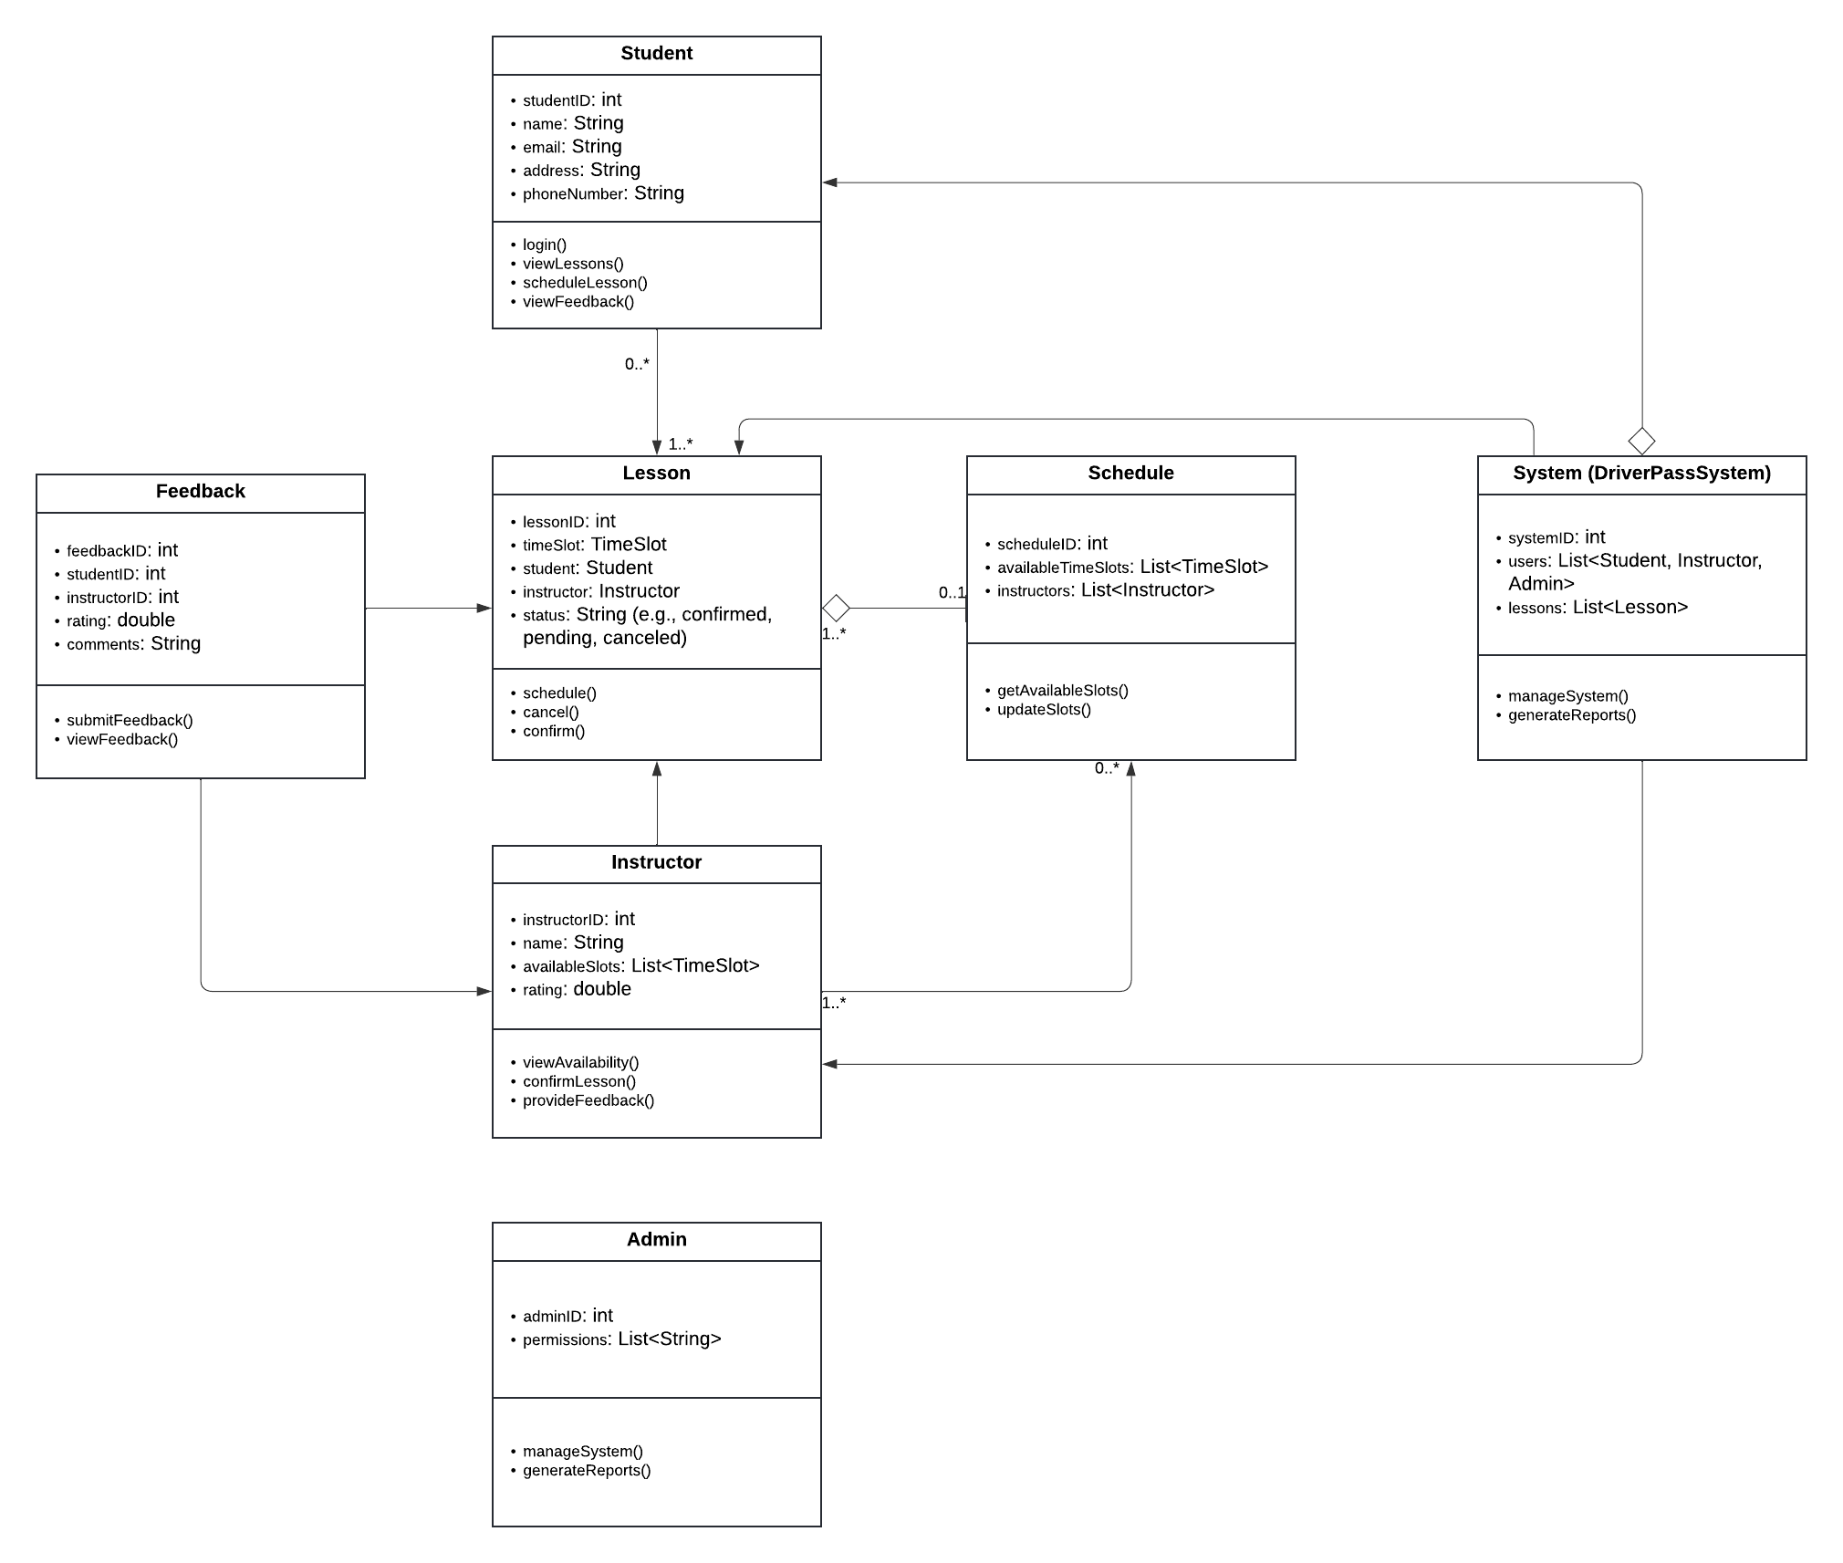

Technical Requirements
[Based on the diagrams you have created, describe the technical requirements of your system. These requirements should address the required hardware, software, tools, and infrastructure necessary for your system design.]
Hardware Requirements:
- Servers:
  - Web Servers: To host the DriverPass system and manage interactions between users, instructors, and administrators.
  - Database Servers: For storing user data, lesson schedules, instructor availability, feedback, and other system data. These servers should have enough storage capacity and processing power to handle multiple simultaneous requests.
  - Backup Servers: For storing backups of user data and lesson schedules to prevent data loss in case of system failure.
- Client Devices:
  - The system must support desktops, laptops, tablets, and smartphones, allowing students, instructors, and administrators to access the system from various devices. This requires devices with internet connectivity and web browsers.
- Network Infrastructure:
  - A reliable and high speed network to handle communications between the system's various components, including servers and client devices.
Software Requirements:
- Operating System:
  - The servers should run on a server operating system like Linux or Windows Server which are some of the best operating systems to choose from for stability.
- Database Management System:
  - Relational Database (MySQL, PostgreSQL): To store structured data such as student information, lesson schedules, feedback, and system reports.
  - NoSQL Database (Optional): For handling unstructured data or high throughput requirements (MongoDB).
- Web Technologies:
  - Front end Frameworks (React, Angular, or Vue.js): To build responsive and dynamic user interfaces that support various devices.
  - Back end Frameworks (e.g., Node.js, Django, or .NET): For managing business logic, user authentication, session management, and handling API requests.
- API Services:
  - REST or GraphQL APIs: To facilitate communication between the front-end, back-end, and database layers. These will allow the retrieval and updating of schedule information, instructor data, and lesson feedback.
- Security Software:
  - SSL certificates for encrypting data exchanged between clients and servers.
  - Firewalls, intrusion detection systems, and anti-virus software to secure the system from external threats.
Tools and Infrastructure:
- Development Tools:
  - Version Control (Git, GitHub): To track changes in the code and collaborate among developers.
  - CI/CD Pipelines (Jenkins, GitLab CI): For automating the testing, building, and deployment of the system.
- Cloud Hosting (Optional):
  - If cloud based infrastructure is preferred, services like AWS, Azure, or Google Cloud can be used to host the DriverPass system, providing scalable server resources, databases, and storage options.
- Testing Tools:
  - Automated Testing Tools (Selenium): To test the functionality of the system across different devices and browsers.
  - Performance Monitoring (New Relic): To monitor system performance and optimize server response times.
With this setup the DriverPass system will run smoothly across multiple devices and be able to handle a large number of students and instructors, ensuring proper scheduling and feedback management.

